Process Flow Documentation: OptimAlze Buddy – AI-Powered Government Services Assistant
1.0 System Overview & Core Value Proposition
OptimAlze Buddy transforms fragmented government-citizen interactions into a seamless, intelligent conversational experience. The system acts as a 24/7 digital clerk that understands, validates, and executes public service requests through three core capabilities: policy-accurate information retrieval, agentic task execution, and intelligent document validation.
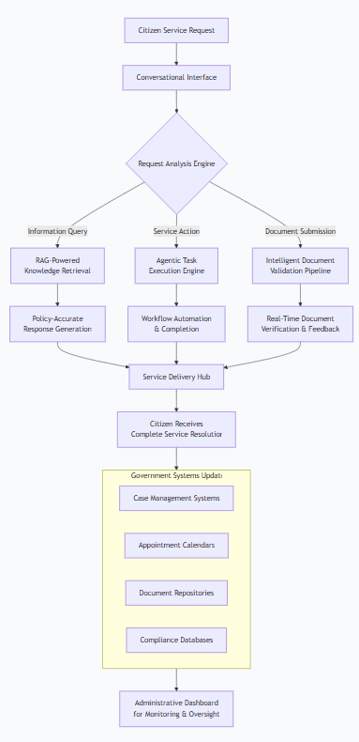
Diagram 1: Holistic System Value Chain – Illustrating how OptimAlze Buddy integrates three core capabilities to resolve citizen service requests end-to-end
2.0 End-to-End Citizen Interaction Flow
The complete citizen journey from initial query to service resolution follows an intelligent, adaptive pathway that minimizes friction and maximizes success rates.
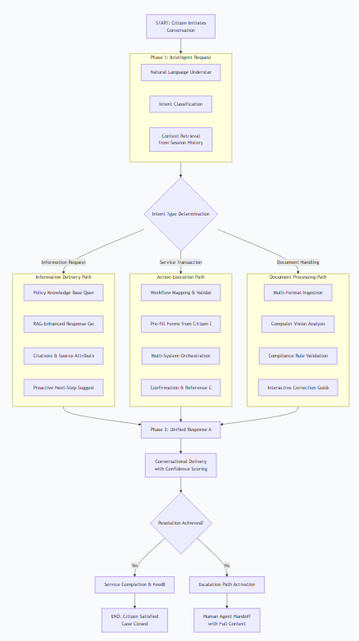
Diagram 2: Complete Citizen Service Journey – Showing the adaptive pathways for different request types
3.0 Conversational Interface & Intent Processing
The system begins by understanding citizen needs through sophisticated natural language processing and context management.
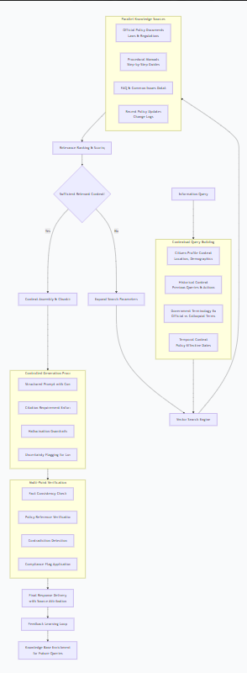
Diagram 3: Intelligent Intent Processing Flow – Demonstrating how the system understands and clarifies citizen requests
4.0 RAG-Powered Knowledge Retrieval System
For information requests, the system retrieves accurate, policy-grounded answers while preventing hallucinations.
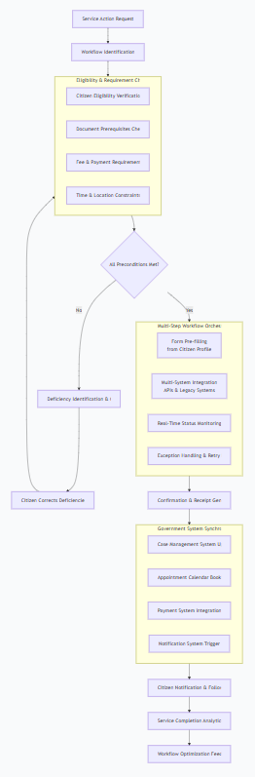
Diagram 4: RAG Knowledge Retrieval Pipeline – Showing how policy-accurate responses are generated with verification safeguards
5.0 Agentic Task Execution Engine
For service actions, the system orchestrates complex government workflows through intelligent automation.
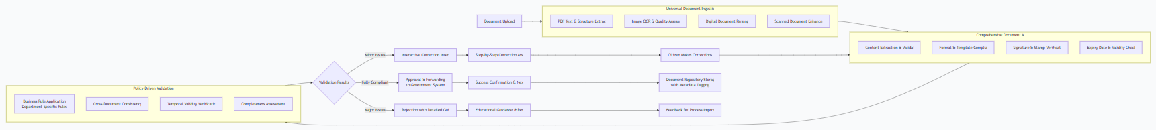
Diagram 5: Agentic Task Execution Flow – Illustrating how complex government services are automated end-to-end
6.0 Intelligent Document Validation Pipeline
Document submissions undergo rigorous, real-time validation to prevent application rejections.
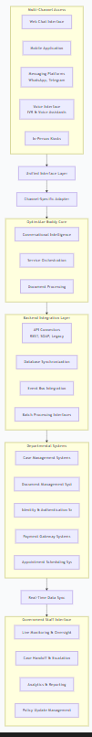
Diagram 6: Document Validation & Correction Flow – Showing how documents are validated and citizens are guided through corrections
7.0 Multi-Channel Integration Architecture
OptimAlze Buddy seamlessly integrates across citizen touchpoints and government backend systems.
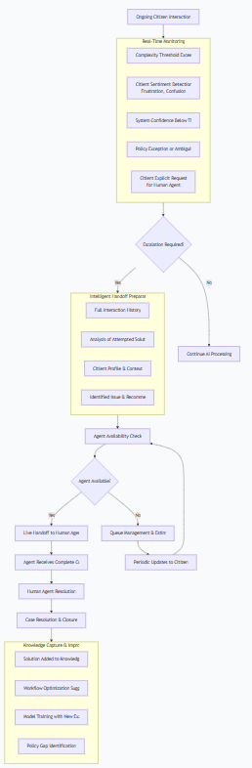
*Diagram 7: Integrated Multi-Channel Architecture* – Illustrating end-to-end connectivity from citizen to government systems
8.0 Human-AI Collaboration & Escalation
The system intelligently determines when human intervention is required and ensures smooth handoffs.
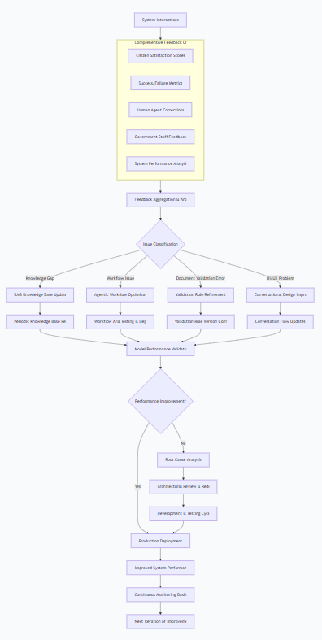
*Diagram 8: Intelligent Human-AI Handoff Flow* – Showing how the system escalates complex cases while preserving context
9.0 Continuous Learning & System Improvement
The system evolves through multiple feedback loops and performance monitoring.
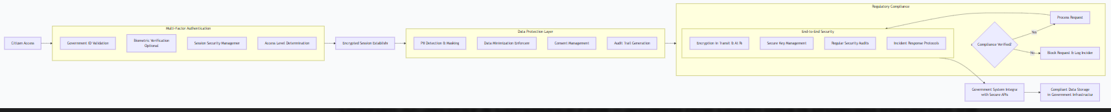
Diagram 9: Continuous Learning Ecosystem – Illustrating how feedback drives systematic improvements across all components
10.0 Security, Privacy & Compliance Architecture
The system incorporates multiple layers of security and compliance controls tailored for government services.

Diagram 10: Security & Compliance Flow – Showing how citizen data is protected throughout the interaction

System Configuration Summary
Component | Primary Technology | Key Capability | Update Frequency
Conversational Engine | Transformer-based NLP | Intent classification & context management | Continuous learning
RAG Knowledge Base | Vector embeddings + LLM | Policy-accurate information retrieval | Daily updates
Agentic Workflows | State machines + API orchestration | Multi-step service automation | Weekly optimization
Document Intelligence | Computer vision + OCR | Real-time document validation | Rule updates as needed
Integration Layer | API gateway + adapters | Government system connectivity | As system changes
Performance Metrics Overview
Metric Category | Target Value | Measurement Method | Impact
First-Contact Resolution | >85% of queries | Session completion analysis | Reduces staff workload
Document Acceptance Rate | >95% on first submission | Validation success tracking | Prevents application rejections
Citizen Satisfaction | >4.5/5 rating | Post-interaction surveys | Improves public trust
Response Accuracy | >98% policy compliance | Manual audit sampling | Ensures regulatory compliance
System Availability | 99.9% uptime | Infrastructure monitoring | Enables 24/7 service access

Conclusion
This process flow documentation demonstrates how OptimAlze Buddy transforms government-citizen interactions through intelligent automation. The system's strength lies in its integrated approach—combining accurate information retrieval with actionable service execution and proactive document validation—all within a seamless conversational interface.
Each diagram reveals a carefully orchestrated process designed to reduce administrative burden while improving citizen experience. The modular architecture ensures adaptability across different government departments and service types, while maintaining robust security and compliance standards required for public sector operations.
The system represents a paradigm shift in public service delivery—from fragmented, manual processes to intelligent, unified digital experiences that serve citizens effectively while optimizing government resources.

